# Lab 6: While Loop Guessing Game

Academic Honesty

* The work you turn in is to be your work, not copied from someone else, from the web, or generated by a program.
* Never allow anyone access to your files.
* Never give anyone your password.
* Never share your USB memory or email your files to anyone else.
* Never give anyone a printed copy of your file or an electronic copy.
* Never allow anyone to copy your work.

Purpose

This lab will let us practice writing while loops with if statements

## Functionality

* You will generate a random number between 1 and 100
* You will repeatedly ask the user to guess a number between 1 and 100 until they guess the random number.
* When their guess is too high – let them know
* When their guess is too low – let them know
* If they use more than 5 guesses, tell them they lose, you only get 5 guesses. And stop the game.
* When they win, let them know how many guesses it took them

## Sample Program

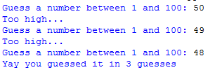

If the user doesn’t guess in 5 guesses, give them an error message.

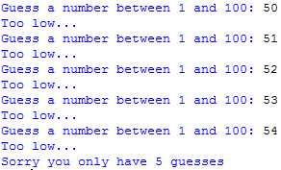

## Submitting your files

* Copy your .py file and move it to your X:\101Labs directory for grading.
* Make sure your file is named Lab6XY.py where XY are your initials
* Print your code, and submit it to your lab instructor at the beginning of your next lab class.

## Grade Breakdown

|  |  |
| --- | --- |
| **Points** | **Expectation** |
| 10% | Comments, listing program, your name, and explaining the code |
| 30% | Correctly Setting up While Loop |
| 30% | Correctly Setting up If Statements |
| 10% | Counting the number of guesses |
| 10% | Generating the random number |
| 10% | Input and Output for user |